Practical 6
Definition : Use Excel Features such as Conditional Formatting, Pivot Tables, Charts, and Data Validation to analyze a Dataset.
Outcomes / Learning : I've learned how to Analyze a Dataset by Performing the features of Conditional Formatting, Pivot Tables, Charts, and Datasets.
Required Tool : The Experiment was performed using a Microsoft Excel Environment which is crucial for performing such Activities.
Working : The Experiment successfully Formats -Conditionally the ‘Amount’, ‘Profit’ & ‘Quantity’ Columns.

For Conditional Formatting :
Step 1 : Select The Desired Columns then press on the Conditional Formatting Icon on The Ribbon above.
Step 2 : Select The Cells you want to Format like from Top or Botton or any specific.
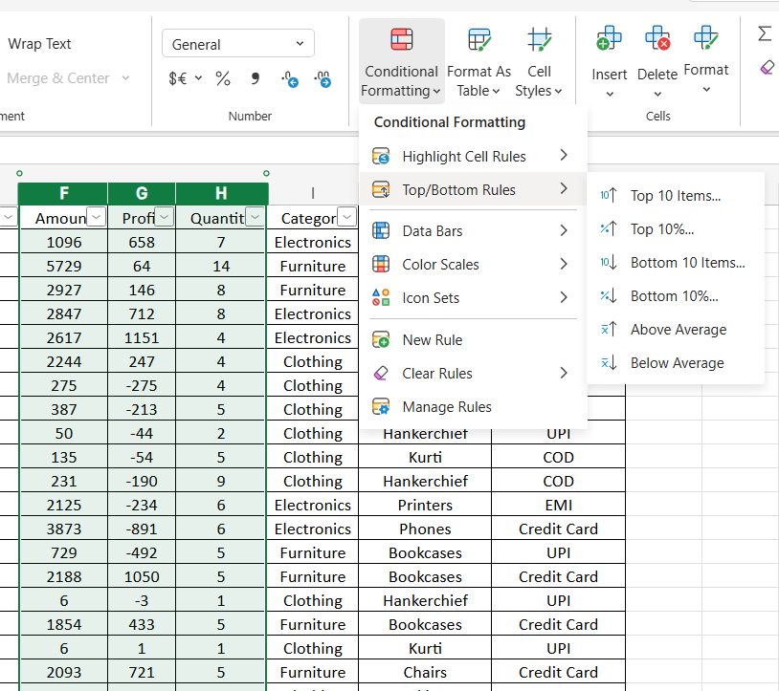
Step 3: Format the way you desire, ( In our case, we’ve Colored FG of The Top and Bottom 20% value with Green and Red Respectively).
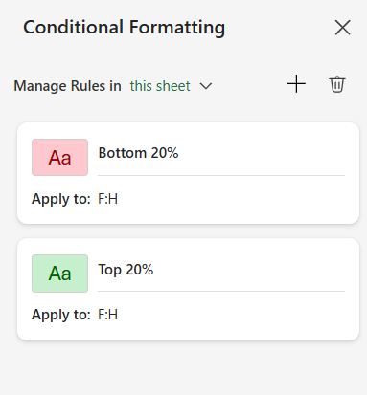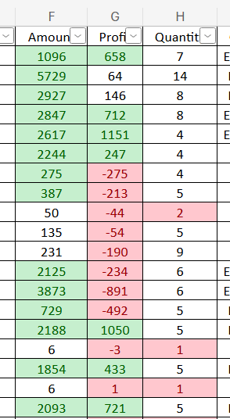
For Pivot Tables :
Step 1 : Select your Data by Dragging the Cursor over The Spreadsheet, then select Pivot Table Feature in The Insert Tab and Then make a New Sheet for The Specified Range.
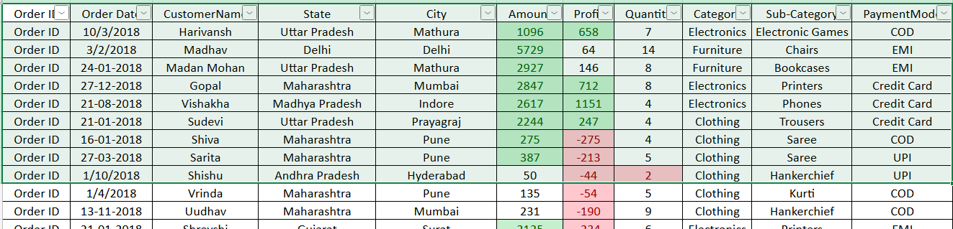
Step 2 : Configure Pivot table for Analysis by Dragging Rows, Column and Values.
Step 3 : Create a Attractive Pivot Chart using Slicers.
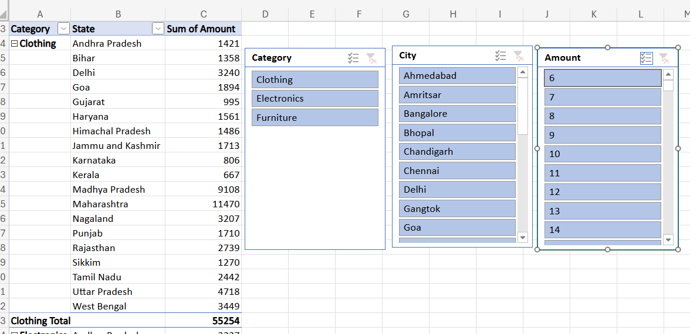
For Charts :
Step 1 : Select the Data: Click and drag to select the data for the chart. You'll need the column headers and data for Order ID (Column E), Amount (Column F), and Profit (Column G).
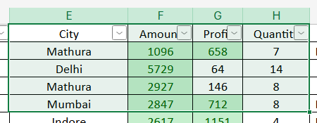
Step 2 : Go to the Insert tab on the Excel ribbon, In the Charts group, click on the icon for Insert Column or Bar Chart (it looks like a small bar graph), Under the 2-D Column section, select Clustered Column.
Excel will generate a chart showing blue columns for 'Amount' and orange columns for 'Profit' for each Order ID.
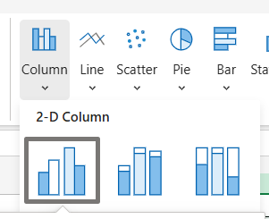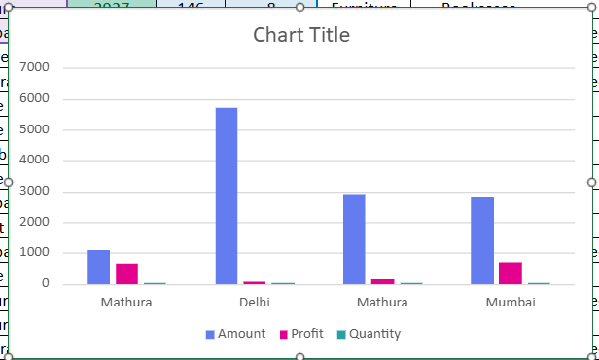

For Data Validation :
Step 1 : Select the Range: Click on the cell H2 and drag down to select all the data cells in the Quantity column that you want to validate.
Step 2 : Open Data Validation: Go to the Data tab on the Excel ribbon, and in the "Data Tools" group, click on Data Validation.
Step 3 : Set Validation Criteria.
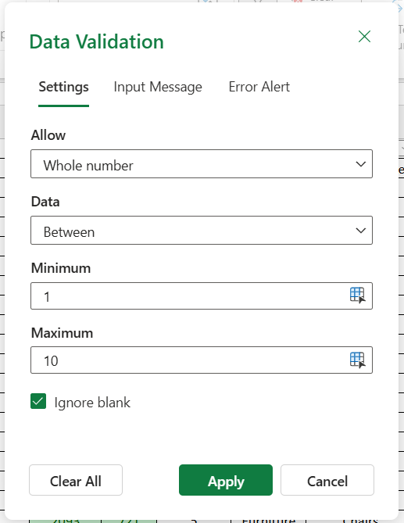
Step 4 : Add an Input Message.
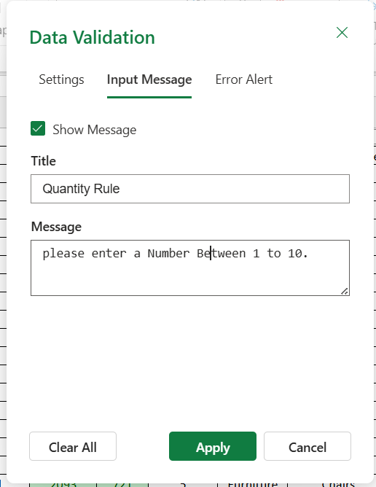

Step 5 : Set an Error Alert.
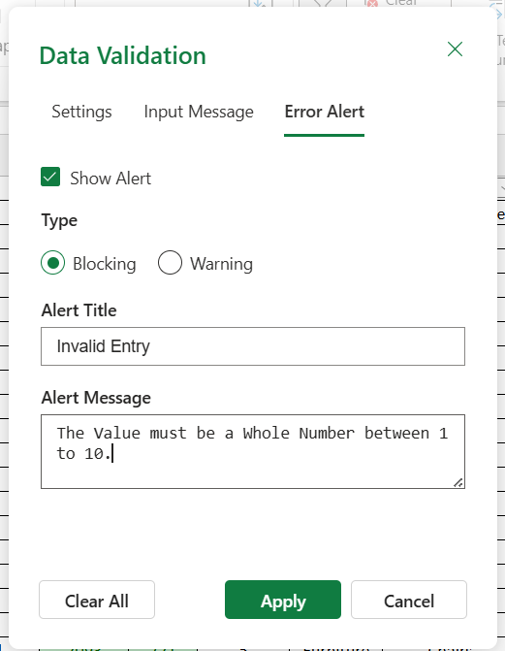
Step 6 : Click OK.

